Advantages of ITC
XG (11-20): Isothermal titration calorimetry (ITC) is now routinely used to directly characterize the thermodynamics of protein-ligand binding interactions and the kinetics of enzyme-catalyzed reactions.

- A typical binding interaction between a ligand and a receptor molecule is illustrated below
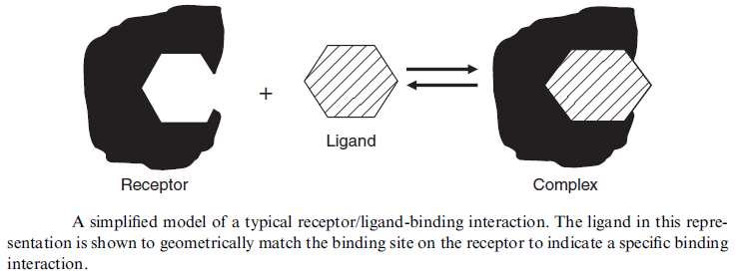

The following equations are provided as a brief review of the relevant thermodynamic relationships:

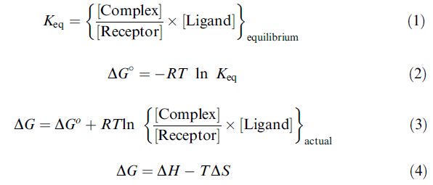 | Keq (K) is the equilibrium constant,  [X] is the molar equilibrium (or actual) concentration of species X,  ΔGº is the standard Gibbs free energy change,  R is the universal gas constant,  T is the temperature in Kelvin,  ΔG is the actual Gibbs free energy change,  ΔH is the enthalpy change,  ΔS is the entropy change for complex formation.

The unique advantage of the ITC experiment is that it is possible in a single experiment, to obtain accurate values for K (or ΔG), ΔH, -TΔS, and n, where n is the stoichiometry of the interaction (mol ligand/mol complex).

- A typical enzyme substrate interaction is illustrated below
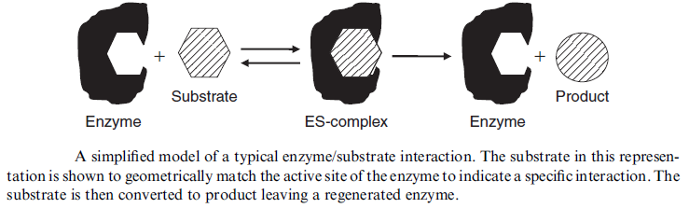

The following equations are provided as a review of the relevant kinetic relationships:
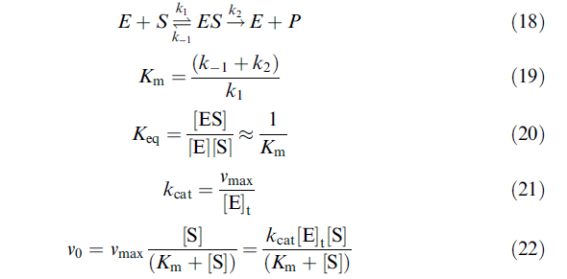 | k1, k-1, and k2 are the rate constants for the forward and reverse reactions in the reaction scheme,  Km is the Michaelis constant,  K is the binding constant,  kcat is the turnover number,  v0 is the initial velocity,  vmax is the maximal velocity (when [ES] = [E]t), [X] is the molar concentration of species X.
This heat rate is simply equal to the reaction rate multiplied by the enthalpy change for the reaction as shown in 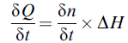.

The raw calorimetric signal is thus a direct measure of the reaction rate making the calorimeter an ideal instrument for kinetic studies.

ITC is also sensitive enough (noise levels >0.01 mcal/sec) that enzyme concentrations and volumes required are similar to those needed for spectrophotometric analyses.

In summary, ITC is the only one capable of measuring not only the magnitude of the binding affinity but also the magnitude of the two thermodynamic terms that define the binding affinity: the enthalpy (ΔH) and entropy (ΔS) changes. Because isothermal titration calorimetry has the capability to measure different energetic contributions to the binding affinity, it provides a unique bridge between computational and experimental analysis. As such, it is increasingly becoming an essential tool in molecular design.

