Summary of advantages and limitations of FP assays

Advantages:
- FP assays do not require separation of bound and free ligand. This allows ligand binding to be quantified without perturbing the equilibrium, making it suitable for measurement of low-affinity interactions (more specifically, interactions with fast dissociation rates).
- They can provide high-throughput, economical, rapid and convenient screens for large numbers of fluorescent ligands.
- FP assays are non-destructive, thereby allowing repetitive measurements of the same sample under different conditions (e.g., different temperatures).

Disadvantages:
- The initial optimization of FP assays is likely to be time-consuming, thereafter they are easily automated.
- All FP assays require a fluorescent ligand. This may require development of procedures for conjugation of the ligand to a reactive fluorophore (many of these are available from Invitrogen, Sigma-Aldrich and other suppliers) and subsequent purification of the conjugate. It may even be necessary to synthesize a form of the ligand suitable for conjugation.
- Fluorophores are likely to affect the interaction. In the worst-case scenario, it may be impracticable to obtain a fluorescent ligand that interacts effectively with a target protein; FP would then be impossible.
- Other methods, such as ITC, can provide more direct, and perhaps more reliable, access to these thermodynamic characteristics of protein-ligand interactions.

Differential scanning calorimetry (DSC)

The DSC method for measuring binding constant is indirect, compared for example to ITC, because the estimate binding Kb is made from measurements on the equilibrium between folded and unfolded protein rather than that between bound and unbound forms. DSC is a technique able to study thermally induced transitions and particularly, the conformational transitions of biological macromolecules (for example between the folded and the unfolded structure of a protein or between single and double stranded DNA). DSC measures the excess heat capacity of a solution (Cp) of the molecule of interest as a function of temperature (Figure below). The transition is recognized as a sharp endothermic peak centred at Tm and the maximum in Cp occurs directly at Tm. Integration of the Cp versus T curve yields the transition enthalpy (ΔH°m) and the shift in the baseline yields the ΔCp. DSC is the only method for the direct determination of ΔH°m.
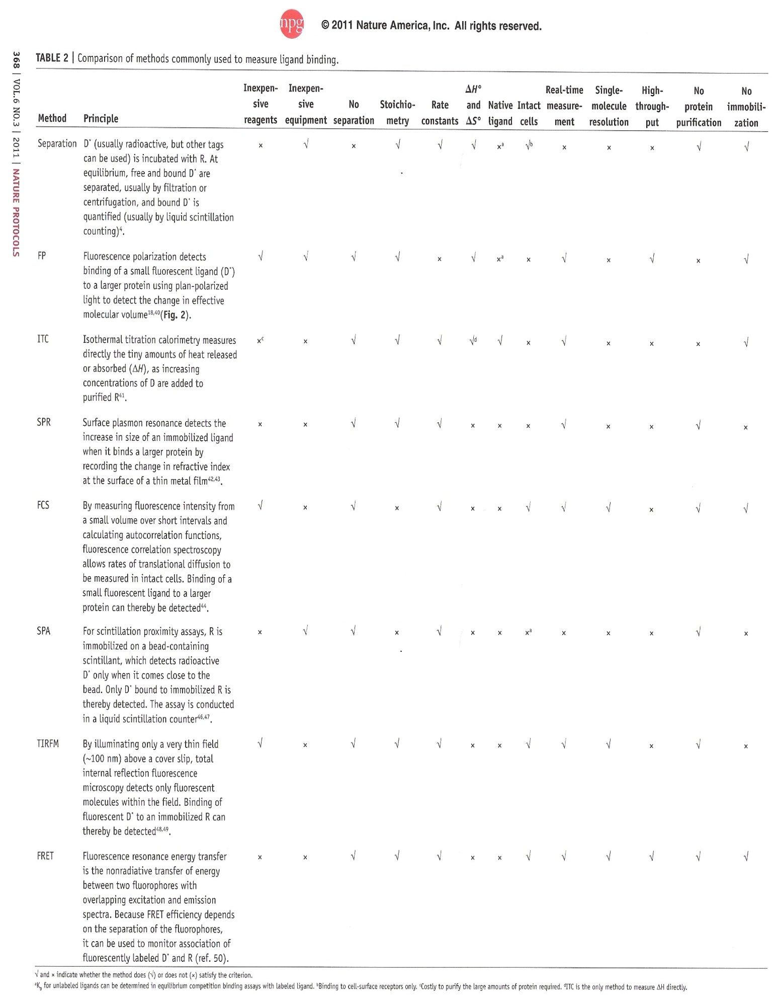

References
- Nature Protocols (2011) 6(3): 365-387.
- Int. J. Mol. Sci. (2009) 10: 2752-2762.
- Enzyme Engineering Methods in Molecular Biology (2013) 978: 21-30.
- Review of Scientific Instruments (2012) 83: 105104.
- Methods (2009) 47: 198-205.
- Current Medicinal Chemistry (2005) 12: 2011-2020.
- Current opinion in Structural Biology (2001) 11: 560-566.

